Introduction:
One of the greatest challenges of our century is controlling the emission of greenhouse gases (GHGs) into the atmosphere (Amundson, R., Beaudeu, L., 2018). Greenhouse gases such as CO2, CH4 and N2O which contribute 76, 16 and 6% respectively to the enhanced greenhouse effect (IPCC, 2013). South Asia is a focal point and particularly vulnerable to climate change (World Bank, 2018). With its rapidly growing population, the region faces immense challenges in terms of allocation and management land and water resources. Agriculture is the primary source of livelihood and consists largely of small-scale farmers who practice intensive farming leading to depletion of nutrients and organic carbon from soil (Jat et al., 2022). In 2018, agriculture contributed to 9.3 billion tones od carbon dioxide equivalent (Gt CO2 eq) (FAO, 2018).
Rice (Oryza Sativa) is the stapple food in South Asia (Towprayoon et al., 2005) and rice cultivation is a major source of these gases. Rice cultivation is responsible for 48% of the GHG emissions from croplands(Qian et al., 2023). Traditional methods of rice cultivation require immense amounts of irrigation water, labor for transplanting and tending of fields (Gangopadhyay et al., 2022). Rice fields account for about 9% of the world’s cropland area and have environmental conditions beneficial for soil organic carbon storage (about 14%), methane emission and somewhat nitrous oxide emissions (Liu et al., 2021).
In Bangladesh, rice-fallow-rice is a common cropping pattern. Rice cultivation releases C from soil as CO2 and/or CH4 depending on the type of cultivation system; continuous submergence releases less CO2 and more CH4 compared to alternate-wetting and drying (Rahman et al., 2016).
Although agricultural soils e.g. paddy soils are considered a source of GHG emission, its potential as a sink is not one that can overlooked (Rajkishore et al., 2015). Soils possess 2-3 times more carbon storage capacity compared to the atmosphere and hence have the potential to mitigate GHG emission and climate change (Jat et al., 2022). Nonetheless it is only possible to achieve benefits from this process when the soil has the ideal C: N ration, otherwise it can lead to emission for nitrous oxide through N mineralization (Mbee et al., 2024).
Rice soils can retain tremendous amount of resilient carbon compared to all the other terrestrial ecosystems (Liu et al., 2021); organic matter accumulates in rice systems as a result of submerged conditions. Submerged soils create anaerobic conditions where free oxygen (electron acceptor) is absent hence the decomposition of organic matter depend on the availability of ferric ions or sulphates as electron acceptor. In comparison to oxygen, these ions are less proficient in decomposition of organic matter and consequently result in slower decomposition of organic matter (Sahrawat, 2005).
The influence of rice cultivation on soil carbon sequestration can be understood from a study in Cixi City, Zhejiang province China, by Pan et al., 2024, where rice and non-rice cultivation following coastal tidal flat reclamation was conducted to investigate the dynamics of SOC and TN sequestration over a long duration. According to the results, over time the SOC content was 0.7-1.4 times, and the TN content was 0.6-11 times more in rice paddies in the cultivated layer compared to non-rice soils. SOC increased upto 34.2 g kg⁻¹ in RP700 and TN upto 2.0 g kg⁻¹ in RP300. Values for SOC and TN were relatively constant in the deeper layer compared to the cultivated layer (Pan et al., 2024).
Whether rice ecosystems act as a source or sink of carbon and what changes occur in soil organic carbon levels under different management practices remains ambiguous (Rahman et al., 2016). The objective of our study is –
- Elucidate the relationship between soil carbon and nitrogen sequestration and physicochemical properties of soils under long term rice and non-rice cultivation.
- Quantification of net ecosystem Carbon balance considering all the possible influx and outflux of carbon to assess whether the low land rice ecology behave as a source or sink or carbon.
- Analysis of how paddy soils accumulate carbon by considering the factors responsible for carbon sequestration.
- The extent to which land type and land use changes affect this process.

Methodology:
We investigated 13 sites of the lowland Haor basins on greater Sylhet, Moulovibazar and Habiganj district.
Site Selection: The soils series under investigation were- Ajmiriganj, Balaganj, Goainghat, Hakaluki, Kanairghat, Phagu, Sarail, Sulla, Terchibari, zakiganj, Kulaura and a BRRI site.

Series Name | Location | Family Name | Subgroup | Great Groups | Suborder | Order | General Soil Type
Ajmiraganj | 24°30'05.4"N 91°22'36.9"E | Clayey, mixed, non-acid Typic Haplaquepts | Typic Haplaquepts | Haplaquepts | Aquepts | Inceptisol | Non-Calcareous Grey Floodplain Soils
Balaganj | 24°25'52.8"N 91°13'37.6"E | Loamy,mixed,non-acid Aeric Haplaquepts | Aeric Haplaquepts | Haplaquepts | Aquepts | Inceptisol | Non-Calcareous Grey Floodplain Soils
Goanighat | 24°54'48.4"N 91°01'49.6"E | Loamy,mixed,non-acid Aeric Haplaquepts | Aeric Haplaquepts | Haplaquepts | Aquepts | Inceptisol | Non-Calcareous Grey Floodplain Soils
Hakaluki | 24°18'04.1"N 91°32'03.5"E | Histosols | Undefined |  |  | Histosols | Peat
Kanairghat | 24°16'57.7"N 91°14'39.5"E | Clayey, mixed non-acid Aeric Haplaquepts | Aeric Haplaquepts | Haplaquepts | Aquepts | Inceptisol | Non-Calcareous Grey Floodplain Soils
Phagu | 24°54'09.2"N 91°00'18.9"E | Clayey, mixed non-acid Aeric Haplaquepts | Aeric Haplaquepts | Haplaquepts | Aquepts | Inceptisol | Non-Calcareous Grey Floodplain Soils
Sarail | 24°06'13.4"N 91°08'40.5"E | Loamy, mixed acid Thapto-histic Haplaquepts | Thapto-histic Haplaquepts | Haplaquepts | Aquepts | Inceptisol | Non-Calcareous Grey Floodplain Soils
Sulla | 24°35'31.9"N 91°18'01.4"E | Clayey, mixed, non-acid Typic Haplaquepts | Typic Haplaquepts | Haplaquepts | Aquepts | Inceptisol | Non-Calcareous Grey Floodplain Soils
Terchibari | 24°48'38.2"N 91°22'49.8"E | Clayey, mixed, non-acid Typic Haplaquepts | Typic Haplaquepts | Haplaquepts | Aquepts | Inceptisol | Non-Calcareous Grey Floodplain Soils
Zakiganj |  |  |  |  |  | Inceptisol/ Ultisol | Brown Hill soils
Kulaura |  |  |  |  |  | Inceptisol/ Ultisol | Brown Hill Soils
BRRI Site

Geology and Geomorphology of Wetlands in Sylhet /Lowland areas in Sylhet:
The Sylhet lowland/trough in a sub-basin of the Bengal Basin, lying on the northeastern extremity of Bangladesh is tectonically complex. It is also locally known as the haor area of Bangladesh and consists of mainly – Sunamganj, Moulovibazar Sylhet Kishorganj and Netrokona districts (Md. Salauddin and A.K.M Saiful Islam, 2011). The haor basin is low-lying and bowl-shaped covering 6000 sq km, mostly in the Sunamganj district. All of this land is below 8m and is seasonally flooded for 7-8 months to depths of 5 m or more (NERP, 1995).
The Sylhet trough is bounded by the Indian Shield on the west, the Shillong Plateau on the north, and the Chittagong Tripura fold belt of the Indo Burman ranges on the southeast (Samuel Y. Johnson, Abu Md. Nur Alam, 1990). It is dynamically subsiding; the trough has subsided 10 m in the past 200 years (Simon Dixon, 2015) and has insignificant topographic relief (elevations of less than 5 to 20 m) and consists of several lakes and swamps. The sediment thickness of this trough expands from 13 to 17 km (Evans, 1964; Hiller,K and Elahi, M, 1984) mostly from the Cenozoic age. The area is developed by a faulted anticline structure; the folds are northward facing, fractures and gas-bearing and involve young sedimentary layers (Pliocene and Pleistocene) and are steeply tilted (Samuel Y. Johnson, Abu Md. Nur Alam, 1990). The Dauki Fault forms the contact between the Shilong Plateau and Sylhet trough; the fault is almost entirely straight and flat topographically. The key geologic formations found: Sylhet limestone (fossiliferous), Barail (Oligocene rocks) in the northern and easter margins, Surma formation (sandstones and shales), Tipam (Pliocene sandstones and clays), Dupi Tila Formations (Pliocene and Pleistocene fluvial deposits) and the most recent Dihing formation from the Pleistocene age (Samuel Y. Johnson, Abu Md. Nur Alam, 1990).

Investigation of Soil Properties:
- Soil pH: pH value is the measure of hydrogen ion and expresses the acidity or alkalinity of the soil. pH of the soil samples was measured using a pH meter as described by Jackson (1967). Soil was added to water in the ratio 1:2.5 to make the suspension while intermittently stirring it with a glass rod for 30 minutes. The pH was determined by inserting the electrode of the pH meter (Das, 2014).
- Soil Organic Carbon (SOC): The organic carbon was determined by Walkley-Black (WB) method (Walkley and Black, 1934) which determines soil organic carbon by oxidizing carbon with acidic dichromate (Cr2O7 2- ). The Walkley-Black (WB) method has been used widely for the past 50 years because of its simplicity and expeditiousness(Soil Science, n.d.). In this method, different concentrations of sulfuric acid used to determine the oxidizable C content (Abulaizi et al., 2025) The oxidation step was followed by titration of excess dichromate with ferrous sulfate. The organic carbon was calculated from the difference between the total dichromate added and the amount of dichromate left unreacted after organic carbon oxidation.
% Organic Carbon = (V blank – V sample) x M Fe x 0.003 x 100 x f x mcf /W
Where, V blank= volume of titrant in blank, mL
V = volume of titrant in sample, mL
W= weight of soil, g
mcf = Moisture correction factor
MFe= Molarity of FeSO₄ solution
f = correction factor (Walkley-Black method assumes ~77% oxidation efficiency, so typically 1.33)
The relative ratio of SOC content was first calculated as follow-
(RRSOC ¼ SOCbelow=SOCsurface ð1Þ)
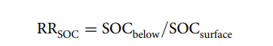
Where, SOCsurface is the SOC content (g kg−1) of surface soil and SOCbelow is the SOC content below the surface soil for various depths in the profile.
The Relative Carbon Sequestration Rate (CSR) was calculated to estimate changes in soil organic carbon (SOC) over time (Publications - IPCC-TFI, n.d.). The formula is:
CSR=SOCpresent−SOCprevious/Years elapsed

The SOC storage in each soil layer was calculated according to the following formula (Haefele et al.,2014)
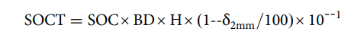
where SOC is SOC content (g kg−1) and and BD is bulk density (g cm−3), H is soil depth (cm) and δ2mm is the fraction (%) of fragments >2 mm in the soil. Here the >2 mm fraction of the total mass is usually negligible.

- Total Nitrogen: Total nitrogen was determined using the classical kjeldahl Method devised in 1883. This process consists of three major steps-
(1) Wet Acidic (conc. H2SO4) digestion of the soil sample in a long-necked digestion flask, converting all the nitrogen to NH4+ form.
(2) Transformation of NH4+ to NH3 and distillation of the NH3. The distillation flask is left one third full to carry out the distillation correctly (Feinberg et al., 1993).
(3) The ammonia from the distillation was collected in an excess boric acid solution and determined by back titration with standard alkali solution (Purificación Sáez-Plaza, 2013). The titration must be carried out as soon as possible after the distillation is complete to ensure that the temperature of the distillate doesn’t exceed 25°C. The digestion takes between 20-30 minutes to several hours depending on the sample (Chemat et al., 1998). According to Kjeldahl, the sample should be heated with sulfuric acid, with or without phosphoric acid until the solution turns clear. Potassium permanganate is added gradually and cautiously to avoid the danger of nitrogen loss from a vigorous reaction (Sáez-Plaza et al., 2013). It is important to carry out blank experiments to make up for any error caused by impurities in the reagent.

- Particle Size Analysis:
The percentage of sand, silt and clay is determined by particle size analysis by hydrometer method as proposed by Bouyoucos (Bouyoucos, 1962). It is based on Stoke’s law, which governs the rate of sedimentation of particles in suspended water. Physical dispersion of soil aggregates followed by chemical dispersion by sodium hexametaphosphate is carried out to remove the cations such as Ca2+, Al3+ etc. which bind the aggregates together. A suspension is made by inserting a wooden plunger into the sedimentation cylinder and hydrometer readings are obtained at 40s and at 2 hours (Ana V. Silbermann et al., 2024). The hydrometer readings are corrected for temperature and density. A Marshal’s triangle by the United States Department of Agriculture (USDA, 1951) is used to determine the textural class of each of the horizons.

- Bulk Density:
Bulk density was determined by the core method as described by Blake and Hartge (1986) which is applicable for coarse fragment or peds (G.R. Blake, K. H. Hartge, 1986). This primarily uses the excavation method; a pit was opened, and its dimensions were measured using a measuring tape. This was used to determine the volume of the excavation, hence volume of the soil. Representative soil sampling was done at different depths, and the samples were oven-dried at a consistent temperature of 105C till they reached a constant weight before the oven-dried weight was measured. The following equation was used to determine the bulk density:
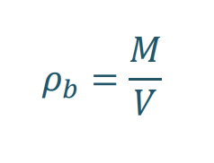 Where, Pb= bulk density (g/cm^3)
M= mass of oven dried soil (g)
V= total volume of soil excavated (g/cm^3)
Alternatively, the volume can be determined using a coating of a water repellent substance on a clod of known weight and measuring its weight in air and consequently while immersed in a liquid of known density, using the Archimedes’ principle.

- Cation Exchange Capacity:
Cation Exchange capacity (CEC) was measured using ammonium-acetate method (pH=7) (H.D Chapman, 1965). 25g soil was mixed with 500 ml water in a flask, and 125ml of 1M ammonium acetate (NH4OAc) was added and allowed to stand overnight. Filter the suspension and a clear filter was obtained. The soil was washed with NH4OAc a few times and the supernatant were collected. It was then washed with 95% ethanol to remove any excess saturating solution and discard the leachate. The ammonium saturated soil was mixed with 25ml of 1M KCL. The supernatant was collected to a 250mL volumetric flask, and the soil was discarded (Ross & Ketterings, n.d.) . The NH4-N in the KCL was determined by distillation in alkaline conditions to volatilize the NH3 and collected in boric acid mixed indicator solution. The amount of NH4 was determined by titration against 0.1N H2SO4; a blank experiment was also conducted. CEC is calculated using:
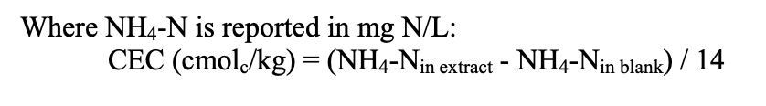

Results:
Our database included information from thirteen soil series from the Sylhet basin between the 24° N and 91°E. Most of these locations were lowland regions, except for Kulaura and Zakiganj, which had higher elevations (ref). The soil organic carbon Stock (SOC_{stock}) was computed for the soil series under investigation and based on the difference in SOC_{stock,} the carbon sequestration rate (CSR) was determined using the formula:
$$Carbon Sequestraion Rate \left(CSR\right)=\frac{SOC Stock present-SOC stock previous}{years elapsed}$$

Positive values of CSR are indicative of increase in carbon content. The SOC_{stock} for low land regions ranges from 83 g/kg to 1400g/kg, whereas in highland regions, they belong between 69 g/kg to 105 g/kg. Bulk density of the sites is within the range of 1.39 g/cm3 to 2.04 g/cm3, with an average value of 1.72 g/cm3.
According to the analysis of carbon stock in the topsoil and subsoil of the selected sites, most showed a higher SOC_{stock} in the subsoil ranging from 33 g/kg to 220 g/kg.

Correlation analysis using Pearson Correlation test indicated that, paddy SOC stocks are mostly determined by nitrogen content (total nitrogen) with which it showed a strong positive correlation in the previous dataset, soil pH which is negatively correlated and to a lesser extent by the clay content. This was further reinstated by regression analysis of the parameters, where a strong positive correlation between SOC_{stock} and total nitrogen content (at p<0.05) was found making it the strongest predictor of soil carbon stock; Soil pH also showed a strong negative relationship with SOC_{stock} at p<0.05. Relationship of SOC_{stock} with clay was rather weak at all significance levels but displayed a very strong relationship with cation exchange capacity (CEC) of the soil.

SOC Stock vs Total Nitrogen:
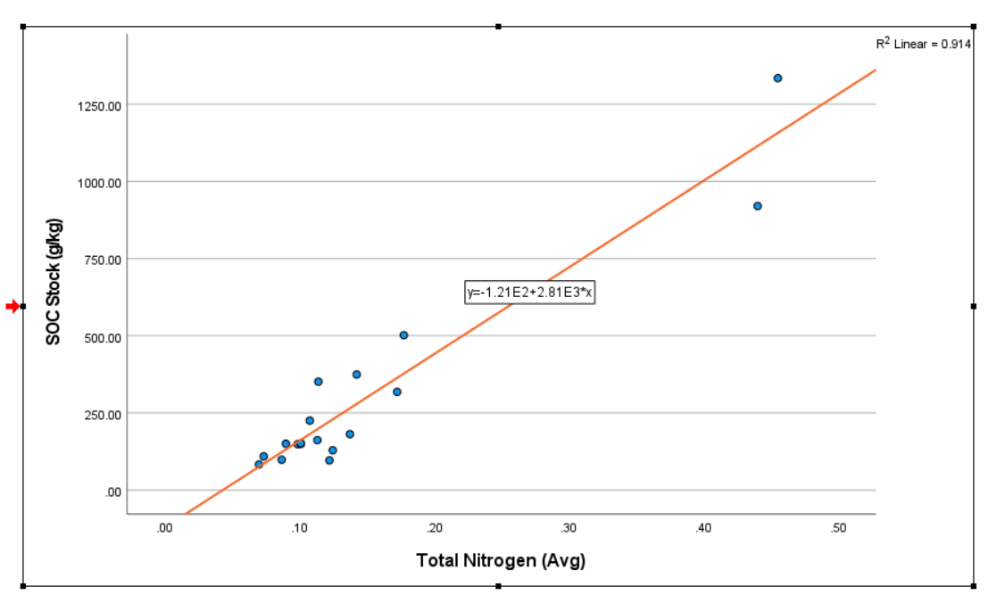

SOC Stock vs soil pH:

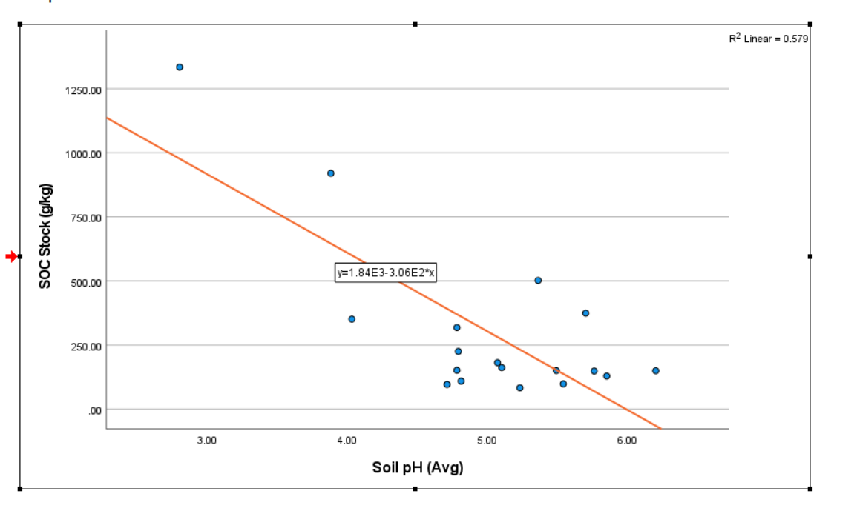

SOC Stock vs Clay:

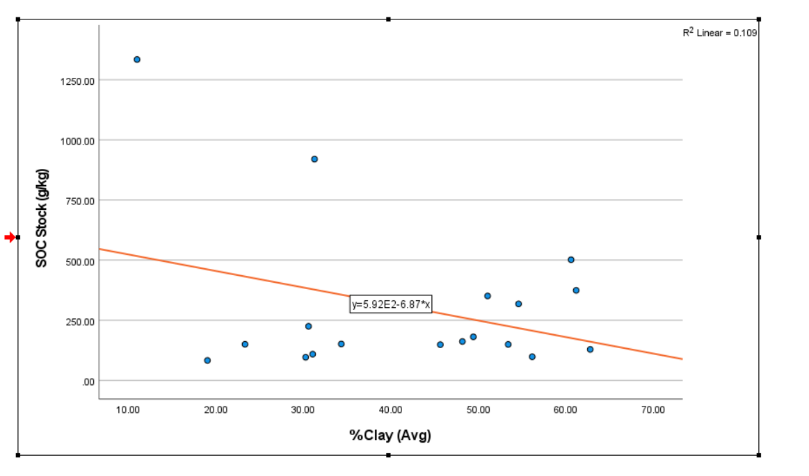

CEC vs Clay:

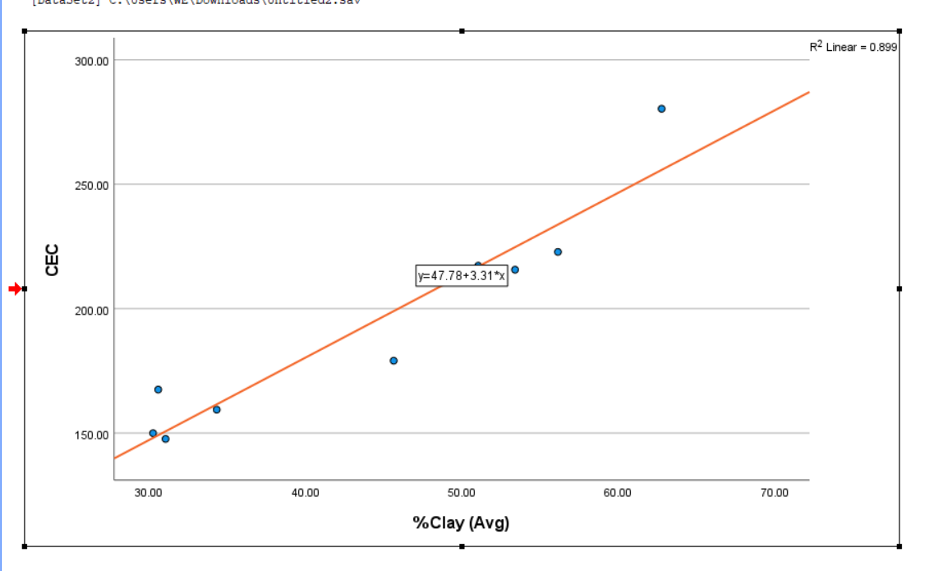

Since nitrogen content was proven to be the strongest predictor of soil carbon stock, a regression analysis of Carbon Sequestration Rate (CSR) showed a strong negative correlation, suggesting that, higher nitrogen content is associated with lower rates of carbon sequestration; this can be since higher nitrogen content enhances the decomposition process of organic matter in soil (Alam et al., 2019).
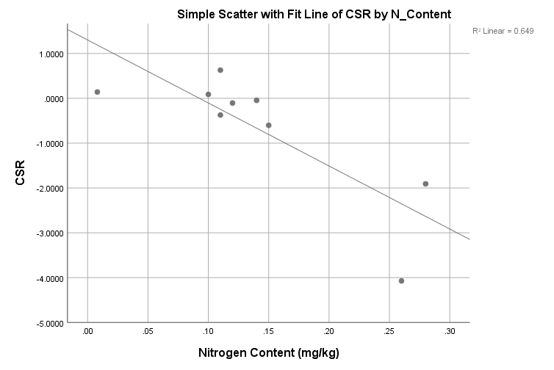

Regression Equation: CSR =1.301−14.054×N_{Content}

According to paired t-tests of SOC_{stock} values of present and previous data, a statistically significant relationship was found between the values for the topsoil (0-30 cm) with the effect size indicating a medium to large difference; no such relationship could be found for the SOC_{stock} values of subsoil (30-100cm).

Discussion:
Soil organic carbon and nitrogen are both components of soil organic matter and hence have a strong positive relationship. Under aerated conditions the concentration of NO3⁻–N remains higher than in submerged soils where NH4⁺–N builds up (Alam et al., 2019). Under waterlogged soil conditions, N mineralization reaches its termination point at NH4⁺ production which results in NH4⁺–N accumulation in the system (Sahrawat, 2010).

Mechanism of Carbon Sequestration on Paddy Soils
Rice cultivation globally covers a total area of about 153 million ha (Lal, 2004; IPCC, 2007) and research suggests that paddy soils have a higher potential for carbon sequestration than upland soils, though the exact processes that contribute to long-term soil organic carbon (SOC) storage remain insufficiently documented (Chen et Al-2021-Environmental Science and Pollution Research, n.d.). Various land use systems of semi-arid tropics (SAT) shown that paddy systems had highest content of organic carbon and nitrogen irrespective of bioclimatic zones, land use under agricultural and horticultural systems (Ramesh et al., 2006). Rice grown on paddy soils have the highest carbon density among all terrestrial ecosystems (Stern et al., 2007) and therefore they constitute an important carbon stock.
Flood water covers rice fields during most parts of rice cultivation. The rice field ecosystem during rice cultivation can be divided into (1) floodwater, (2) plow layer, and (3) subsoil layer beneath the plow layer. The plow layer is again subdivided as specific niches for soil microorganisms into (a) shallow oxidized surface layer, (b) reduced bulk soil beneath the oxidized layer, (c) rice rhizosphere, (d) plant residues such as rice straw and stubble, and (e) percolating water (Kimura et al., 2004). Ponnamperuma (1972) explains that under these anaerobic conditions, both the decomposition of amended organic matter and mineralization of native SOC are lower than those under aerobic conditions (Witt et al., 2000; Guo and Lin, 2001). The characteristic of anaerobic turnover is 1. incomplete decomposition and 2. Lower energy of fermentation and result in the synthesis of fewer microbial cells per unit carbon degraded. Only 2-5 % of the substrate carbon assimilated by anaerobic microbes compared with 30-40% by fungi in aerobe systems which indicates that the lack of oxygen for microbial activity under submerged conditions decreases the decomposition rate (Jenkinson, 1988). As oxygen supply to the soil virtually ceases upon flooding. Soon oxygen trapped in the soil is exhausted during respiration by aerobic microorganisms. With the onset of anaerobiosis, facultative and strict anaerobes become predominant and during anaerobic respiration, soil constituents, NO3-, Mn4+, Fe3+, SO4 2-, CO2 and H+ ions serve as electron acceptors and are consequently reduced, almost in a thermodynamic sequence but with some overlap, to N2, Mn2+, Fe2+, S2-, CH,4, and H2, respectively. Thus, these chemical changes are almost always initiated by biological reduction-oxidation processes catalysed by oxygen-stress situations. In anaerobic environments, the suppression of aerobic microbial activity and the consequent constrained production of pivotal enzymes, such as phenol oxidase, are proposed in O2‐stress conditions (Freeman et al., 2001). Hence, mineralization rates of organic substrates are much slower because of thermodynamic constraints on microbial decomposition (Keiluweit et al., 2017).
Thus, in submerged soils, the formation of recalcitrant complexes with organic matter renders them less available for microbial attack. Moreover, the combination of biological nitrogen fixation with overall higher primary productivity and decreased humification lead to net accumulation of organic matter in wetland soils.
Another crucial process is iron cycling, in rice paddies that experience is seasonal wetting and drying (Sahrawat, 2004). ferrous iron (Fe²⁺) oxidizes During dry periods into ferric iron (Fe³⁺), while ferric iron undergoes reduction in flooded conditions. This cycle restricts organic carbon oxidation and controlling methane emissions, as iron serves as an alternative electron acceptor in microbial respiration and thus influences carbon dynamics.
When soil remains submerged for extended periods, it encourages the accumulation of stable organic carbon pools, providing in carbon sequestration (Mandal et al., 2008). However, the formation of humic substances is most effective under moderately oxidizing conditions, too much oxygen leads to complete decomposition and carbon loss, while too little oxygen slows down the chemical reactions needed for stabilizing carbon. Regular wetting and drying cycles help maintain balance between them, preventing stagnation and promoting the reactions necessary for carbon stabilization (Post et al., 2004).

Land Use Data:

Soil Series | Present Land Use | Previous Land use
Ajmiriganj |  | Irrigated Boro-Fallow
Balaganj |  | Jute-Transplated Aman-Fallow/Rabi Crops
Goainghat |  | Rabi Crops-Fallow
Hakaluki |  | Boro-Fallow
Kanairghat |  | Grassland
Phagu |  | Boro-Fallow
Sarail |  | Irrigated Boro
Sulla |  | Boro-Fallow
Terchibari |  | Boro-Fallow
Zakiganj
Kulaura
BRRI Site

References:
Abulaizi, M., Chen, M., Tian, Y., Hu, Y., Han, D., Hu, Y., Zhou, J., Yang, Z., & Jia, H. (2025). Response of Soil Organic Carbon and Its Components to Alpine Wetland Degradation in Arid Central Asia. Land, 14(2), Article 2. https://doi.org/10.3390/land14020387
Alam et al.,. (2019). Nitrogen transformation and carbon sequestration in wetland paddy field of Bangladesh. Paddy and Water Environment, 17, 677–688.
Alam, Md. A., Rahman, Md. M., Biswas, J. C., Akhter, S., Maniruzzaman, M., Choudhury, A. K., Jahan, M. A. H. S., Miah, Md. M. U., Sen, R., Kamal, M. Z. U., Mannan, Md. A., Shiragi, H. K., Kabir, W., & Kalra, N. (2019). Nitrogen transformation and carbon sequestration in wetland paddy field of Bangladesh. Paddy and Water Environment, 17(4), 677–688. https://doi.org/10.1007/s10333-019-00693-7
Amundson, R., Beaudeu, L.,. (2018). Soil carbon sequestration is an elusive climate mitigation tool. Proc. Natl. Acad. Sci. U.S.A., 115, 11652–11656.
Ana V. Silbermann, Ana V. Silbermann, This person is not on ResearchGate, or hasn’t claimed this research yet., Leonardo Paladino, Deborah Torres, & Andres Beretta. (2024). Soil texture analyses using a hydrometer: Modification of the Bouyoucos method. ResearchGate. https://doi.org/10.4067/S0718-16202014000200013
Chemat, Z., Hadj-Boussaad, D. E., & Chemat, F. (1998). Application of atmospheric pressure microwave digestion to total Kjeldahl nitrogen determination in pharmaceutical, agricultural and food products. Analusis, 26(5), 205–209. https://doi.org/10.1051/analusis:1998133
Chen et al-2021-Environmental Science and Pollution Research. (n.d.). Retrieved March 5, 2025, from https://www.researchgate.net/publication/350398976_Chen_et_al-2021-Environmental_Science_and_Pollution_Research
Das, B. (2014). Physical and Chemical Analysis of Soil Collected from Jaisamand.
Evans. (1964). The tectonic framework of Assam: Geological Society of Indian Journal. 5, 80–96.
FAO. (2018). Emissions due to agriculture. https://openknowledge.fao.org/server/api/core/bitstreams/cc09fbbc-eb1d-436b-a88a-bed42a1f12f3/content
Feinberg, M. H., Ireland-Ripert, J., & Mourel, R. M. (1993). Optimization procedure of open vessel microwave digestion for Kjeldahl nitrogen determination in foods. Analytica Chimica Acta, 272(1), 83–90. https://doi.org/10.1016/0003-2670(93)80378-X
Gangopadhyay, S., Banerjee, R., Batabyal, S., Das, N., Mondal, A., Pal, S. C., & Mandal, S. (2022). Carbon sequestration and greenhouse gas emissions for different rice cultivation practices. Sustainable Production and Consumption, 34, 90–104. https://doi.org/10.1016/j.spc.2022.09.001
G.R. Blake, K. H. Hartge. (1986). Bulk Density. In Methods of Soil Analysis: Part 1 Physical and Mineralogical Methods (2nd ed.). https://doi.org/10.2136/sssabookser5.1.2ed.c13
H.D Chapman. (1965). Cation-Exchange Capacity. In Methods of Siol Analysis: Part 2: Chemical and Microbiological Properties. https://doi.org/10.2134/agronmonogr9.2.c6
Hiller,K and Elahi, M. (1984). Structural Development and hydrocarbon entrapment in the Surma Basin, Bangladesh (northwest Indo-Burman fold belt). 650–663.
IPCC. (2013). Climate Change 2013. In: The Physical Science Basis. Contribution of Working Group I to the Fifth Assessment Report of the Intergovernmental Panel on Climate Change (No. 5). Cambridge University.
Jat, M. L., Chakraborty, D., Ladha, J. K., Parihar, C. M., Datta, A., Mandal, B., Nayak, H. S., Maity, P., Rana, D. S., Chaudhari, S. K., & Gerard, B. (2022). Carbon sequestration potential, challenges, and strategies towards climate action in smallholder agricultural systems of South Asia. Crop and Environment, 1(1), 86–101. https://doi.org/10.1016/j.crope.2022.03.005
Kimura, M., Murase, J., & Lu, Y. (2004). Carbon cycling in rice field ecosystems in the context of input, decomposition and translocation of organic materials and the fates of their end products (CO2 and CH4). Soil Biology and Biochemistry, 36(9), 1399–1416. https://doi.org/10.1016/j.soilbio.2004.03.006
Liu, Y., Ge, T., Van Groenigen, K. J., Yang, Y., Wang, P., Cheng, K., Zhu, Z., Wang, J., Li, Y., Guggenberger, G., Sardans, J., Penuelas, J., Wu, J., & Kuzyakov, Y. (2021). Rice paddy soils are a quantitatively important carbon store according to a global synthesis. Communications Earth & Environment, 2(1), 154. https://doi.org/10.1038/s43247-021-00229-0
Mbee, M., Barigbue, S., John, Dr. C., & O.J, Dr. K. (2024). Carbon and Nitrogen Sequestration Potential of Various Land Use Types in Tai Area, Rivers State. International Journal of Research Publication and Reviews, 5(5), 7894–7905. https://doi.org/10.55248/gengpi.5.0524.1320
Md. Salauddin and A.K.M Saiful Islam. (2011). IDENTIFICATION OF LAND COVER CHANGES OF THE HAOR AREA OF BANGLADESH USING MODIS IMAGES. 3rd International Conference on Water & Flood Management.
NERP. (1995). Specialist Study Wetland Resources (No. Final Report; Northeast Regional Water Management Project, FAP-6). Flood Plan Coordinatin Organization.
Pan, J., Wang, J., & Zhuang, S. (2024). Higher soil carbon and nitrogen sequestration in rice than non-rice soils following land reclamation. Soil and Tillage Research, 237, 105963. https://doi.org/10.1016/j.still.2023.105963
Publications—IPCC-TFI. (n.d.). Retrieved March 5, 2025, from https://www.ipcc-nggip.iges.or.jp/public/2006gl/vol4.html
Qian, H., Zhu, X., Huang, S., Linquist, B., Kuzyakov, Y., Wassmann, R., Minamikawa, K., Martinez-Eixarch, M., Yan, X., Zhou, F., Sander, B. O., Zhang, W., Shang, Z., Zou, J., Zheng, X., Li, G., Liu, Z., Wang, S., Ding, Y., … Jiang, Y. (2023). Greenhouse gas emissions and mitigation in rice agriculture. Nature Reviews Earth & Environment, 4(10), 716–732. https://doi.org/10.1038/s43017-023-00482-1
Rahman, F., Rahman, M. M., Rahman, G. K. M. M., Saleque, M. A., Hossain, A. T. M. S., & Miah, M. G. (2016). Effect of organic and inorganic fertilizers and rice straw on carbon sequestration and soil fertility under a rice–rice cropping pattern. Carbon Management, 7(1–2), 41–53. https://doi.org/10.1080/17583004.2016.1166425
Rajkishore, S. K., Natarajan, S. K., Manikandan, A., Vignesh, N. S., & Balusamy, A. (2015). CARBON SEQUESTRATION IN RICE SOILS: A REVIEW.
Ross, D. S., & Ketterings, Q. (n.d.). Recommended Methods for Determining Soil Cation Exchange Capacity. 493.
Sáez-Plaza, P., Michałowski, T., Navas, M. J., Asuero, A. G., & Wybraniec, S. (2013). An Overview of the Kjeldahl Method of Nitrogen Determination. Part I. Early History, Chemistry of the Procedure, and Titrimetric Finish. Critical Reviews in Analytical Chemistry, 43(4), 178–223. https://doi.org/10.1080/10408347.2012.751786
Sahrawat, K. L. (2005). Fertility and organic matter in submerged rice soils. CURRENT SCIENCE, 88(5).
Samuel Y. Johnson, Abu Md. Nur Alam. (1990). Sedimentation and Techtonic of the Sylhet Trough, Northeastern Bangladesh (Open-File Report Nos. 90–313; Open-File Report). United States Department of Interior Geological Survey.
Simon Dixon. (2015). The Sylhet Trough – Nature’s giant settling basin. River Management Blog. https://therivermanagementblog.wordpress.com/2015/02/18/the-sylhet-trough-natures-giant-settling-basin/
Soil Science. (n.d.). Retrieved March 5, 2025, from https://journals.lww.com/soilsci/citation/1934/01000/AN_EXAMINATION_OF_THE_DEGTJAREFF_METHOD_FOR.3.aspx.
Towprayoon, S., Smakgahn, K., & Poonkaew, S. (2005). Mitigation of methane and nitrous oxide emissions from drained irrigated rice fields. Chemosphere, 59(11), 1547–1556. https://doi.org/10.1016/j.chemosphere.2005.02.009
World Bank. (2018). South Asia’s Hotspots. World Bank. https://www.worldbank.org/en/region/sar/publication/south-asias-hotspots
Abulaizi, M., Chen, M., Tian, Y., Hu, Y., Han, D., Hu, Y., Zhou, J., Yang, Z., & Jia, H. (2025). Response of Soil Organic Carbon and Its Components to Alpine Wetland Degradation in Arid Central Asia. Land, 14(2), Article 2. https://doi.org/10.3390/land14020387
Alam et al.,. (2019). Nitrogen transformation and carbon sequestration in wetland paddy field of Bangladesh. Paddy and Water Environment, 17, 677–688.
Alam, Md. A., Rahman, Md. M., Biswas, J. C., Akhter, S., Maniruzzaman, M., Choudhury, A. K., Jahan, M. A. H. S., Miah, Md. M. U., Sen, R., Kamal, M. Z. U., Mannan, Md. A., Shiragi, H. K., Kabir, W., & Kalra, N. (2019). Nitrogen transformation and carbon sequestration in wetland paddy field of Bangladesh. Paddy and Water Environment, 17(4), 677–688. https://doi.org/10.1007/s10333-019-00693-7
Amundson, R., Beaudeu, L.,. (2018). Soil carbon sequestration is an elusive climate mitigation tool. Proc. Natl. Acad. Sci. U.S.A., 115, 11652–11656.
Ana V. Silbermann, Ana V. Silbermann, This person is not on ResearchGate, or hasn’t claimed this research yet., Leonardo Paladino, Deborah Torres, & Andres Beretta. (2024). Soil texture analyses using a hydrometer: Modification of the Bouyoucos method. ResearchGate. https://doi.org/10.4067/S0718-16202014000200013
Chemat, Z., Hadj-Boussaad, D. E., & Chemat, F. (1998). Application of atmospheric pressure microwave digestion to total Kjeldahl nitrogen determination in pharmaceutical, agricultural and food products. Analusis, 26(5), 205–209. https://doi.org/10.1051/analusis:1998133
Chen et al-2021-Environmental Science and Pollution Research. (n.d.). Retrieved March 5, 2025, from https://www.researchgate.net/publication/350398976_Chen_et_al-2021-Environmental_Science_and_Pollution_Research
Das, B. (2014). Physical and Chemical Analysis of Soil Collected from Jaisamand.
Evans. (1964). The tectonic framework of Assam: Geological Society of Indian Journal. 5, 80–96.
FAO. (2018). Emissions due to agriculture. https://openknowledge.fao.org/server/api/core/bitstreams/cc09fbbc-eb1d-436b-a88a-bed42a1f12f3/content
Feinberg, M. H., Ireland-Ripert, J., & Mourel, R. M. (1993). Optimization procedure of open vessel microwave digestion for Kjeldahl nitrogen determination in foods. Analytica Chimica Acta, 272(1), 83–90. https://doi.org/10.1016/0003-2670(93)80378-X
Gangopadhyay, S., Banerjee, R., Batabyal, S., Das, N., Mondal, A., Pal, S. C., & Mandal, S. (2022). Carbon sequestration and greenhouse gas emissions for different rice cultivation practices. Sustainable Production and Consumption, 34, 90–104. https://doi.org/10.1016/j.spc.2022.09.001
G.R. Blake, K. H. Hartge. (1986). Bulk Density. In Methods of Soil Analysis: Part 1 Physical and Mineralogical Methods (2nd ed.). https://doi.org/10.2136/sssabookser5.1.2ed.c13
H.D Chapman. (1965). Cation-Exchange Capacity. In Methods of Siol Analysis: Part 2: Chemical and Microbiological Properties. https://doi.org/10.2134/agronmonogr9.2.c6
Hiller,K and Elahi, M. (1984). Structural Development and hydrocarbon entrapment in the Surma Basin, Bangladesh (northwest Indo-Burman fold belt). 650–663.
IPCC. (2013). Climate Change 2013. In: The Physical Science Basis. Contribution of Working Group I to the Fifth Assessment Report of the Intergovernmental Panel on Climate Change (No. 5). Cambridge University.
Jat, M. L., Chakraborty, D., Ladha, J. K., Parihar, C. M., Datta, A., Mandal, B., Nayak, H. S., Maity, P., Rana, D. S., Chaudhari, S. K., & Gerard, B. (2022). Carbon sequestration potential, challenges, and strategies towards climate action in smallholder agricultural systems of South Asia. Crop and Environment, 1(1), 86–101. https://doi.org/10.1016/j.crope.2022.03.005
Kimura, M., Murase, J., & Lu, Y. (2004). Carbon cycling in rice field ecosystems in the context of input, decomposition and translocation of organic materials and the fates of their end products (CO2 and CH4). Soil Biology and Biochemistry, 36(9), 1399–1416. https://doi.org/10.1016/j.soilbio.2004.03.006
Liu, Y., Ge, T., Van Groenigen, K. J., Yang, Y., Wang, P., Cheng, K., Zhu, Z., Wang, J., Li, Y., Guggenberger, G., Sardans, J., Penuelas, J., Wu, J., & Kuzyakov, Y. (2021). Rice paddy soils are a quantitatively important carbon store according to a global synthesis. Communications Earth & Environment, 2(1), 154. https://doi.org/10.1038/s43247-021-00229-0
Mbee, M., Barigbue, S., John, Dr. C., & O.J, Dr. K. (2024). Carbon and Nitrogen Sequestration Potential of Various Land Use Types in Tai Area, Rivers State. International Journal of Research Publication and Reviews, 5(5), 7894–7905. https://doi.org/10.55248/gengpi.5.0524.1320
Md. Salauddin and A.K.M Saiful Islam. (2011). IDENTIFICATION OF LAND COVER CHANGES OF THE HAOR AREA OF BANGLADESH USING MODIS IMAGES. 3rd International Conference on Water & Flood Management.
NERP. (1995). Specialist Study Wetland Resources (No. Final Report; Northeast Regional Water Management Project, FAP-6). Flood Plan Coordinatin Organization.
Pan, J., Wang, J., & Zhuang, S. (2024). Higher soil carbon and nitrogen sequestration in rice than non-rice soils following land reclamation. Soil and Tillage Research, 237, 105963. https://doi.org/10.1016/j.still.2023.105963
Publications—IPCC-TFI. (n.d.). Retrieved March 5, 2025, from https://www.ipcc-nggip.iges.or.jp/public/2006gl/vol4.html
Qian, H., Zhu, X., Huang, S., Linquist, B., Kuzyakov, Y., Wassmann, R., Minamikawa, K., Martinez-Eixarch, M., Yan, X., Zhou, F., Sander, B. O., Zhang, W., Shang, Z., Zou, J., Zheng, X., Li, G., Liu, Z., Wang, S., Ding, Y., … Jiang, Y. (2023). Greenhouse gas emissions and mitigation in rice agriculture. Nature Reviews Earth & Environment, 4(10), 716–732. https://doi.org/10.1038/s43017-023-00482-1
Rahman, F., Rahman, M. M., Rahman, G. K. M. M., Saleque, M. A., Hossain, A. T. M. S., & Miah, M. G. (2016). Effect of organic and inorganic fertilizers and rice straw on carbon sequestration and soil fertility under a rice–rice cropping pattern. Carbon Management, 7(1–2), 41–53. https://doi.org/10.1080/17583004.2016.1166425
Rajkishore, S. K., Natarajan, S. K., Manikandan, A., Vignesh, N. S., & Balusamy, A. (2015). CARBON SEQUESTRATION IN RICE SOILS: A REVIEW.
Ross, D. S., & Ketterings, Q. (n.d.). Recommended Methods for Determining Soil Cation Exchange Capacity. 493.
Sáez-Plaza, P., Michałowski, T., Navas, M. J., Asuero, A. G., & Wybraniec, S. (2013). An Overview of the Kjeldahl Method of Nitrogen Determination. Part I. Early History, Chemistry of the Procedure, and Titrimetric Finish. Critical Reviews in Analytical Chemistry, 43(4), 178–223. https://doi.org/10.1080/10408347.2012.751786
Sahrawat, K. L. (2005). Fertility and organic matter in submerged rice soils. CURRENT SCIENCE, 88(5).
Samuel Y. Johnson, Abu Md. Nur Alam. (1990). Sedimentation and Techtonic of the Sylhet Trough, Northeastern Bangladesh (Open-File Report Nos. 90–313; Open-File Report). United States Department of Interior Geological Survey.
Simon Dixon. (2015). The Sylhet Trough – Nature’s giant settling basin. River Management Blog. https://therivermanagementblog.wordpress.com/2015/02/18/the-sylhet-trough-natures-giant-settling-basin/
Soil Science. (n.d.). Retrieved March 5, 2025, from https://journals.lww.com/soilsci/citation/1934/01000/AN_EXAMINATION_OF_THE_DEGTJAREFF_METHOD_FOR.3.aspx.
Towprayoon, S., Smakgahn, K., & Poonkaew, S. (2005). Mitigation of methane and nitrous oxide emissions from drained irrigated rice fields. Chemosphere, 59(11), 1547–1556. https://doi.org/10.1016/j.chemosphere.2005.02.009
World Bank. (2018). South Asia’s Hotspots. World Bank. https://www.worldbank.org/en/region/sar/publication/south-asias-hotspots
Haefele, S. M., Nelson, A. & Hijmans, R. J. Soil quality and constraints in
global rice production. Geoderma 235, 250–259 (2014)

Abulaizi, M., Chen, M., Tian, Y., Hu, Y., Han, D., Hu, Y., Zhou, J., Yang, Z., & Jia, H. (2025). Response of Soil Organic Carbon and Its Components to Alpine Wetland Degradation in Arid Central Asia. Land, 14(2), Article 2. https://doi.org/10.3390/land14020387
Alam et al.,. (2019). Nitrogen transformation and carbon sequestration in wetland paddy field of Bangladesh. Paddy and Water Environment, 17, 677–688.
Alam, Md. A., Rahman, Md. M., Biswas, J. C., Akhter, S., Maniruzzaman, M., Choudhury, A. K., Jahan, M. A. H. S., Miah, Md. M. U., Sen, R., Kamal, M. Z. U., Mannan, Md. A., Shiragi, H. K., Kabir, W., & Kalra, N. (2019). Nitrogen transformation and carbon sequestration in wetland paddy field of Bangladesh. Paddy and Water Environment, 17(4), 677–688. https://doi.org/10.1007/s10333-019-00693-7
Amundson, R., Beaudeu, L.,. (2018). Soil carbon sequestration is an elusive climate mitigation tool. Proc. Natl. Acad. Sci. U.S.A., 115, 11652–11656.
Ana V. Silbermann, Ana V. Silbermann, This person is not on ResearchGate, or hasn’t claimed this research yet., Leonardo Paladino, Deborah Torres, & Andres Beretta. (2024). Soil texture analyses using a hydrometer: Modification of the Bouyoucos method. ResearchGate. https://doi.org/10.4067/S0718-16202014000200013
Chemat, Z., Hadj-Boussaad, D. E., & Chemat, F. (1998). Application of atmospheric pressure microwave digestion to total Kjeldahl nitrogen determination in pharmaceutical, agricultural and food products. Analusis, 26(5), 205–209. https://doi.org/10.1051/analusis:1998133
Chen et al-2021-Environmental Science and Pollution Research. (n.d.). Retrieved March 5, 2025, from https://www.researchgate.net/publication/350398976_Chen_et_al-2021-Environmental_Science_and_Pollution_Research
Das, B. (2014). Physical and Chemical Analysis of Soil Collected from Jaisamand.
Evans. (1964). The tectonic framework of Assam: Geological Society of Indian Journal. 5, 80–96.
FAO. (2018). Emissions due to agriculture. https://openknowledge.fao.org/server/api/core/bitstreams/cc09fbbc-eb1d-436b-a88a-bed42a1f12f3/content
Feinberg, M. H., Ireland-Ripert, J., & Mourel, R. M. (1993). Optimization procedure of open vessel microwave digestion for Kjeldahl nitrogen determination in foods. Analytica Chimica Acta, 272(1), 83–90. https://doi.org/10.1016/0003-2670(93)80378-X
Gangopadhyay, S., Banerjee, R., Batabyal, S., Das, N., Mondal, A., Pal, S. C., & Mandal, S. (2022). Carbon sequestration and greenhouse gas emissions for different rice cultivation practices. Sustainable Production and Consumption, 34, 90–104. https://doi.org/10.1016/j.spc.2022.09.001
G.R. Blake, K. H. Hartge. (1986). Bulk Density. In Methods of Soil Analysis: Part 1 Physical and Mineralogical Methods (2nd ed.). https://doi.org/10.2136/sssabookser5.1.2ed.c13
H.D Chapman. (1965). Cation-Exchange Capacity. In Methods of Siol Analysis: Part 2: Chemical and Microbiological Properties. https://doi.org/10.2134/agronmonogr9.2.c6
Hiller,K and Elahi, M. (1984). Structural Development and hydrocarbon entrapment in the Surma Basin, Bangladesh (northwest Indo-Burman fold belt). 650–663.
IPCC. (2013). Climate Change 2013. In: The Physical Science Basis. Contribution of Working Group I to the Fifth Assessment Report of the Intergovernmental Panel on Climate Change (No. 5). Cambridge University.
Jat, M. L., Chakraborty, D., Ladha, J. K., Parihar, C. M., Datta, A., Mandal, B., Nayak, H. S., Maity, P., Rana, D. S., Chaudhari, S. K., & Gerard, B. (2022). Carbon sequestration potential, challenges, and strategies towards climate action in smallholder agricultural systems of South Asia. Crop and Environment, 1(1), 86–101. https://doi.org/10.1016/j.crope.2022.03.005
Kimura, M., Murase, J., & Lu, Y. (2004). Carbon cycling in rice field ecosystems in the context of input, decomposition and translocation of organic materials and the fates of their end products (CO2 and CH4). Soil Biology and Biochemistry, 36(9), 1399–1416. https://doi.org/10.1016/j.soilbio.2004.03.006
Liu, Y., Ge, T., Van Groenigen, K. J., Yang, Y., Wang, P., Cheng, K., Zhu, Z., Wang, J., Li, Y., Guggenberger, G., Sardans, J., Penuelas, J., Wu, J., & Kuzyakov, Y. (2021). Rice paddy soils are a quantitatively important carbon store according to a global synthesis. Communications Earth & Environment, 2(1), 154. https://doi.org/10.1038/s43247-021-00229-0
Mbee, M., Barigbue, S., John, Dr. C., & O.J, Dr. K. (2024). Carbon and Nitrogen Sequestration Potential of Various Land Use Types in Tai Area, Rivers State. International Journal of Research Publication and Reviews, 5(5), 7894–7905. https://doi.org/10.55248/gengpi.5.0524.1320
Md. Salauddin and A.K.M Saiful Islam. (2011). IDENTIFICATION OF LAND COVER CHANGES OF THE HAOR AREA OF BANGLADESH USING MODIS IMAGES. 3rd International Conference on Water & Flood Management.
NERP. (1995). Specialist Study Wetland Resources (No. Final Report; Northeast Regional Water Management Project, FAP-6). Flood Plan Coordinatin Organization.
Pan, J., Wang, J., & Zhuang, S. (2024). Higher soil carbon and nitrogen sequestration in rice than non-rice soils following land reclamation. Soil and Tillage Research, 237, 105963. https://doi.org/10.1016/j.still.2023.105963
Publications—IPCC-TFI. (n.d.). Retrieved March 5, 2025, from https://www.ipcc-nggip.iges.or.jp/public/2006gl/vol4.html
Qian, H., Zhu, X., Huang, S., Linquist, B., Kuzyakov, Y., Wassmann, R., Minamikawa, K., Martinez-Eixarch, M., Yan, X., Zhou, F., Sander, B. O., Zhang, W., Shang, Z., Zou, J., Zheng, X., Li, G., Liu, Z., Wang, S., Ding, Y., … Jiang, Y. (2023). Greenhouse gas emissions and mitigation in rice agriculture. Nature Reviews Earth & Environment, 4(10), 716–732. https://doi.org/10.1038/s43017-023-00482-1
Rahman, F., Rahman, M. M., Rahman, G. K. M. M., Saleque, M. A., Hossain, A. T. M. S., & Miah, M. G. (2016). Effect of organic and inorganic fertilizers and rice straw on carbon sequestration and soil fertility under a rice–rice cropping pattern. Carbon Management, 7(1–2), 41–53. https://doi.org/10.1080/17583004.2016.1166425
Rajkishore, S. K., Natarajan, S. K., Manikandan, A., Vignesh, N. S., & Balusamy, A. (2015). CARBON SEQUESTRATION IN RICE SOILS: A REVIEW.
Ross, D. S., & Ketterings, Q. (n.d.). Recommended Methods for Determining Soil Cation Exchange Capacity. 493.
Sáez-Plaza, P., Michałowski, T., Navas, M. J., Asuero, A. G., & Wybraniec, S. (2013). An Overview of the Kjeldahl Method of Nitrogen Determination. Part I. Early History, Chemistry of the Procedure, and Titrimetric Finish. Critical Reviews in Analytical Chemistry, 43(4), 178–223. https://doi.org/10.1080/10408347.2012.751786
Sahrawat, K. L. (2005). Fertility and organic matter in submerged rice soils. CURRENT SCIENCE, 88(5).
Samuel Y. Johnson, Abu Md. Nur Alam. (1990). Sedimentation and Techtonic of the Sylhet Trough, Northeastern Bangladesh (Open-File Report Nos. 90–313; Open-File Report). United States Department of Interior Geological Survey.
Simon Dixon. (2015). The Sylhet Trough – Nature’s giant settling basin. River Management Blog. https://therivermanagementblog.wordpress.com/2015/02/18/the-sylhet-trough-natures-giant-settling-basin/
Soil Science. (n.d.). Retrieved March 5, 2025, from https://journals.lww.com/soilsci/citation/1934/01000/AN_EXAMINATION_OF_THE_DEGTJAREFF_METHOD_FOR.3.aspx.
Towprayoon, S., Smakgahn, K., & Poonkaew, S. (2005). Mitigation of methane and nitrous oxide emissions from drained irrigated rice fields. Chemosphere, 59(11), 1547–1556. https://doi.org/10.1016/j.chemosphere.2005.02.009
World Bank. (2018). South Asia’s Hotspots. World Bank. https://www.worldbank.org/en/region/sar/publication/south-asias-hotspots

Abulaizi, M., Chen, M., Tian, Y., Hu, Y., Han, D., Hu, Y., Zhou, J., Yang, Z., & Jia, H. (2025). Response of Soil Organic Carbon and Its Components to Alpine Wetland Degradation in Arid Central Asia. Land, 14(2), Article 2. https://doi.org/10.3390/land14020387
Alam et al.,. (2019). Nitrogen transformation and carbon sequestration in wetland paddy field of Bangladesh. Paddy and Water Environment, 17, 677–688.
Alam, Md. A., Rahman, Md. M., Biswas, J. C., Akhter, S., Maniruzzaman, M., Choudhury, A. K., Jahan, M. A. H. S., Miah, Md. M. U., Sen, R., Kamal, M. Z. U., Mannan, Md. A., Shiragi, H. K., Kabir, W., & Kalra, N. (2019). Nitrogen transformation and carbon sequestration in wetland paddy field of Bangladesh. Paddy and Water Environment, 17(4), 677–688. https://doi.org/10.1007/s10333-019-00693-7
Amundson, R., Beaudeu, L.,. (2018). Soil carbon sequestration is an elusive climate mitigation tool. Proc. Natl. Acad. Sci. U.S.A., 115, 11652–11656.
Ana V. Silbermann, Ana V. Silbermann, This person is not on ResearchGate, or hasn’t claimed this research yet., Leonardo Paladino, Deborah Torres, & Andres Beretta. (2024). Soil texture analyses using a hydrometer: Modification of the Bouyoucos method. ResearchGate. https://doi.org/10.4067/S0718-16202014000200013
Chemat, Z., Hadj-Boussaad, D. E., & Chemat, F. (1998). Application of atmospheric pressure microwave digestion to total Kjeldahl nitrogen determination in pharmaceutical, agricultural and food products. Analusis, 26(5), 205–209. https://doi.org/10.1051/analusis:1998133
Chen et al-2021-Environmental Science and Pollution Research. (n.d.). Retrieved March 5, 2025, from https://www.researchgate.net/publication/350398976_Chen_et_al-2021-Environmental_Science_and_Pollution_Research
Das, B. (2014). Physical and Chemical Analysis of Soil Collected from Jaisamand.
Evans. (1964). The tectonic framework of Assam: Geological Society of Indian Journal. 5, 80–96.
FAO. (2018). Emissions due to agriculture. https://openknowledge.fao.org/server/api/core/bitstreams/cc09fbbc-eb1d-436b-a88a-bed42a1f12f3/content
Feinberg, M. H., Ireland-Ripert, J., & Mourel, R. M. (1993). Optimization procedure of open vessel microwave digestion for Kjeldahl nitrogen determination in foods. Analytica Chimica Acta, 272(1), 83–90. https://doi.org/10.1016/0003-2670(93)80378-X
Gangopadhyay, S., Banerjee, R., Batabyal, S., Das, N., Mondal, A., Pal, S. C., & Mandal, S. (2022). Carbon sequestration and greenhouse gas emissions for different rice cultivation practices. Sustainable Production and Consumption, 34, 90–104. https://doi.org/10.1016/j.spc.2022.09.001
G.R. Blake, K. H. Hartge. (1986). Bulk Density. In Methods of Soil Analysis: Part 1 Physical and Mineralogical Methods (2nd ed.). https://doi.org/10.2136/sssabookser5.1.2ed.c13
H.D Chapman. (1965). Cation-Exchange Capacity. In Methods of Siol Analysis: Part 2: Chemical and Microbiological Properties. https://doi.org/10.2134/agronmonogr9.2.c6
Hiller,K and Elahi, M. (1984). Structural Development and hydrocarbon entrapment in the Surma Basin, Bangladesh (northwest Indo-Burman fold belt). 650–663.
IPCC. (2013). Climate Change 2013. In: The Physical Science Basis. Contribution of Working Group I to the Fifth Assessment Report of the Intergovernmental Panel on Climate Change (No. 5). Cambridge University.
Jat, M. L., Chakraborty, D., Ladha, J. K., Parihar, C. M., Datta, A., Mandal, B., Nayak, H. S., Maity, P., Rana, D. S., Chaudhari, S. K., & Gerard, B. (2022). Carbon sequestration potential, challenges, and strategies towards climate action in smallholder agricultural systems of South Asia. Crop and Environment, 1(1), 86–101. https://doi.org/10.1016/j.crope.2022.03.005
Kimura, M., Murase, J., & Lu, Y. (2004). Carbon cycling in rice field ecosystems in the context of input, decomposition and translocation of organic materials and the fates of their end products (CO2 and CH4). Soil Biology and Biochemistry, 36(9), 1399–1416. https://doi.org/10.1016/j.soilbio.2004.03.006
Liu, Y., Ge, T., Van Groenigen, K. J., Yang, Y., Wang, P., Cheng, K., Zhu, Z., Wang, J., Li, Y., Guggenberger, G., Sardans, J., Penuelas, J., Wu, J., & Kuzyakov, Y. (2021). Rice paddy soils are a quantitatively important carbon store according to a global synthesis. Communications Earth & Environment, 2(1), 154. https://doi.org/10.1038/s43247-021-00229-0
Mbee, M., Barigbue, S., John, Dr. C., & O.J, Dr. K. (2024). Carbon and Nitrogen Sequestration Potential of Various Land Use Types in Tai Area, Rivers State. International Journal of Research Publication and Reviews, 5(5), 7894–7905. https://doi.org/10.55248/gengpi.5.0524.1320
Md. Salauddin and A.K.M Saiful Islam. (2011). IDENTIFICATION OF LAND COVER CHANGES OF THE HAOR AREA OF BANGLADESH USING MODIS IMAGES. 3rd International Conference on Water & Flood Management.
NERP. (1995). Specialist Study Wetland Resources (No. Final Report; Northeast Regional Water Management Project, FAP-6). Flood Plan Coordinatin Organization.
Pan, J., Wang, J., & Zhuang, S. (2024). Higher soil carbon and nitrogen sequestration in rice than non-rice soils following land reclamation. Soil and Tillage Research, 237, 105963. https://doi.org/10.1016/j.still.2023.105963
Publications—IPCC-TFI. (n.d.). Retrieved March 5, 2025, from https://www.ipcc-nggip.iges.or.jp/public/2006gl/vol4.html
Qian, H., Zhu, X., Huang, S., Linquist, B., Kuzyakov, Y., Wassmann, R., Minamikawa, K., Martinez-Eixarch, M., Yan, X., Zhou, F., Sander, B. O., Zhang, W., Shang, Z., Zou, J., Zheng, X., Li, G., Liu, Z., Wang, S., Ding, Y., … Jiang, Y. (2023). Greenhouse gas emissions and mitigation in rice agriculture. Nature Reviews Earth & Environment, 4(10), 716–732. https://doi.org/10.1038/s43017-023-00482-1
Rahman, F., Rahman, M. M., Rahman, G. K. M. M., Saleque, M. A., Hossain, A. T. M. S., & Miah, M. G. (2016). Effect of organic and inorganic fertilizers and rice straw on carbon sequestration and soil fertility under a rice–rice cropping pattern. Carbon Management, 7(1–2), 41–53. https://doi.org/10.1080/17583004.2016.1166425
Rajkishore, S. K., Natarajan, S. K., Manikandan, A., Vignesh, N. S., & Balusamy, A. (2015). CARBON SEQUESTRATION IN RICE SOILS: A REVIEW.
Ross, D. S., & Ketterings, Q. (n.d.). Recommended Methods for Determining Soil Cation Exchange Capacity. 493.
Sáez-Plaza, P., Michałowski, T., Navas, M. J., Asuero, A. G., & Wybraniec, S. (2013). An Overview of the Kjeldahl Method of Nitrogen Determination. Part I. Early History, Chemistry of the Procedure, and Titrimetric Finish. Critical Reviews in Analytical Chemistry, 43(4), 178–223. https://doi.org/10.1080/10408347.2012.751786
Sahrawat, K. L. (2005). Fertility and organic matter in submerged rice soils. CURRENT SCIENCE, 88(5).
Samuel Y. Johnson, Abu Md. Nur Alam. (1990). Sedimentation and Techtonic of the Sylhet Trough, Northeastern Bangladesh (Open-File Report Nos. 90–313; Open-File Report). United States Department of Interior Geological Survey.
Simon Dixon. (2015). The Sylhet Trough – Nature’s giant settling basin. River Management Blog. https://therivermanagementblog.wordpress.com/2015/02/18/the-sylhet-trough-natures-giant-settling-basin/
Soil Science. (n.d.). Retrieved March 5, 2025, from https://journals.lww.com/soilsci/citation/1934/01000/AN_EXAMINATION_OF_THE_DEGTJAREFF_METHOD_FOR.3.aspx.
Towprayoon, S., Smakgahn, K., & Poonkaew, S. (2005). Mitigation of methane and nitrous oxide emissions from drained irrigated rice fields. Chemosphere, 59(11), 1547–1556. https://doi.org/10.1016/j.chemosphere.2005.02.009
World Bank. (2018). South Asia’s Hotspots. World Bank. https://www.worldbank.org/en/region/sar/publication/south-asias-hotspots
Chen et al-2021-Environmental Science and Pollution Research. (n.d.). Retrieved 5 March 2025, from https://www.researchgate.net/publication/350398976_Chen_et_al-2021-Environmental_Science_and_Pollution_Research
Freeman, C., Ostle, N., & Kang, H. (2001). An enzymic ‘latch’ on a globalcarbon store. Nature, 409, 149. https://doi.org/10.1038/35051650
Guo, L. and Lin, E. 2001. Carbon sink in cropland soils and the emission of greenhouse gases from paddy soils: a review of work in China. Chemosphere Glob Change Sci. 3: 413-418.
IPCC. 2007. Climate Change 2007. In: The physical science basis summary for policymakers’. Contribution of Working Group I to the Fourth Assessment Report of the Intergovernmental Panel on Climate Change, 2007. Solomon S, Qin D, Manning M, Chen Z, Marquis M, Averyt KB, Tignor M, Miller HL (eds), Cambridge University Press, United Kingdom and New York.
Jenkinson, D.S., 1988. Soil organic matter and its dynamics. In: Wild, A. (Ed.), Russell's Soil Conditions and Plant Growth, 11th ed. Longman Group UK Limited, pp. 564–607
Keiluweit, M., Wanzek, T., Kleber, M., Nico, P., & Fendorf, S. (2017).Anaerobic microsites have an unaccounted role in soil carbon stabi -lization. Nature Communications, 8, 1771. https://doi.org/10.1038/s4146 7- 017- 01406-6
Kimura, M., Murase, J., & Lu, Y. (2004). Carbon cycling in rice field ecosystems in the context of input, decomposition and translocation of organic materials and the fates of their end products (CO2 and CH4). Soil Biology and Biochemistry, 36(9), 1399–1416. https://doi.org/10.1016/j.soilbio.2004.03.006
Lal, R. 2004. Soil carbon sequestration impacts on global climate change and food security. Science. 304: 1623-1627.
Mandal, B. 2005. Assessment and improvement of soil quality and resilience for rainfed production system. Completion Report. National Agricultural Technology Project, Indian Council of Agricultural Research, New Delhi, p. 30.
Ponnamperuma, F. N. 1972. The chemistry of submerged soils. Adv Agron. 24: 29-96.
Post, W. M., Cesar Izaurralde, R., Jastrow, J. D., Mccarl, B. A., Amonette, J. E., Bailey, V. L., Jardine, P. M., West, T. O. and Zhou, J. 2004. Enhancement of Carbon Sequestration in US Soils. BioSci. 54(10): 895 - 908.
Ramesh, V., Wani, S. P., Rego, T. J. 2007. Chemical Characterization of selected benchmark spots for C sequestration in the Semi-Arid Tropics, India. In: Global Theme on Agro-ecosytems Report no. 32, International Crops Research Institute for the Semi-Arid Tropics (ICRISAT) and Indian Council of Agricultural Research (ICAR), pp.1 106.
Sahrawat, K. L. 2004. Organic matter accumulation in submerged soils. Adv Agron. 81: 169-201.
Stern, J., Wang, Y., Gu, B. and Newman, J. 2007. Distribution and turnover of carbon in natural and constructed wetlands in the Florida Everglades. Appl. Geochem. 22: 1936-1948.
Witt, C., Cassman, K. G., Olk, D. C., Biker, U., Liboon, S. P., Samson, M. I. and Ottow, J. C. G. 2000. Crop rotation and residue management effects on carbon sequestration, nitrogen cycling and productivity of irrigated rice system. Plant Soil. 225: 263-278
Abulaizi, M., Chen, M., Tian, Y., Hu, Y., Han, D., Hu, Y., Zhou, J., Yang, Z., & Jia, H. (2025). Response of Soil Organic Carbon and Its Components to Alpine Wetland Degradation in Arid Central Asia. Land, 14(2), Article 2. https://doi.org/10.3390/land14020387
Alam et al.,. (2019). Nitrogen transformation and carbon sequestration in wetland paddy field of Bangladesh. Paddy and Water Environment, 17, 677–688.
Alam, Md. A., Rahman, Md. M., Biswas, J. C., Akhter, S., Maniruzzaman, M., Choudhury, A. K., Jahan, M. A. H. S., Miah, Md. M. U., Sen, R., Kamal, M. Z. U., Mannan, Md. A., Shiragi, H. K., Kabir, W., & Kalra, N. (2019). Nitrogen transformation and carbon sequestration in wetland paddy field of Bangladesh. Paddy and Water Environment, 17(4), 677–688. https://doi.org/10.1007/s10333-019-00693-7
Amundson, R., Beaudeu, L.,. (2018). Soil carbon sequestration is an elusive climate mitigation tool. Proc. Natl. Acad. Sci. U.S.A., 115, 11652–11656.
Ana V. Silbermann, Ana V. Silbermann, This person is not on ResearchGate, or hasn’t claimed this research yet., Leonardo Paladino, Deborah Torres, & Andres Beretta. (2024). Soil texture analyses using a hydrometer: Modification of the Bouyoucos method. ResearchGate. https://doi.org/10.4067/S0718-16202014000200013
Chemat, Z., Hadj-Boussaad, D. E., & Chemat, F. (1998). Application of atmospheric pressure microwave digestion to total Kjeldahl nitrogen determination in pharmaceutical, agricultural and food products. Analusis, 26(5), 205–209. https://doi.org/10.1051/analusis:1998133
Chen et al-2021-Environmental Science and Pollution Research. (n.d.). Retrieved March 5, 2025, from https://www.researchgate.net/publication/350398976_Chen_et_al-2021-Environmental_Science_and_Pollution_Research
Das, B. (2014). Physical and Chemical Analysis of Soil Collected from Jaisamand.
Evans. (1964). The tectonic framework of Assam: Geological Society of Indian Journal. 5, 80–96.
FAO. (2018). Emissions due to agriculture. https://openknowledge.fao.org/server/api/core/bitstreams/cc09fbbc-eb1d-436b-a88a-bed42a1f12f3/content
Feinberg, M. H., Ireland-Ripert, J., & Mourel, R. M. (1993). Optimization procedure of open vessel microwave digestion for Kjeldahl nitrogen determination in foods. Analytica Chimica Acta, 272(1), 83–90. https://doi.org/10.1016/0003-2670(93)80378-X
Gangopadhyay, S., Banerjee, R., Batabyal, S., Das, N., Mondal, A., Pal, S. C., & Mandal, S. (2022). Carbon sequestration and greenhouse gas emissions for different rice cultivation practices. Sustainable Production and Consumption, 34, 90–104. https://doi.org/10.1016/j.spc.2022.09.001
G.R. Blake, K. H. Hartge. (1986). Bulk Density. In Methods of Soil Analysis: Part 1 Physical and Mineralogical Methods (2nd ed.). https://doi.org/10.2136/sssabookser5.1.2ed.c13
H.D Chapman. (1965). Cation-Exchange Capacity. In Methods of Siol Analysis: Part 2: Chemical and Microbiological Properties. https://doi.org/10.2134/agronmonogr9.2.c6
Hiller,K and Elahi, M. (1984). Structural Development and hydrocarbon entrapment in the Surma Basin, Bangladesh (northwest Indo-Burman fold belt). 650–663.
IPCC. (2013). Climate Change 2013. In: The Physical Science Basis. Contribution of Working Group I to the Fifth Assessment Report of the Intergovernmental Panel on Climate Change (No. 5). Cambridge University.
Jat, M. L., Chakraborty, D., Ladha, J. K., Parihar, C. M., Datta, A., Mandal, B., Nayak, H. S., Maity, P., Rana, D. S., Chaudhari, S. K., & Gerard, B. (2022). Carbon sequestration potential, challenges, and strategies towards climate action in smallholder agricultural systems of South Asia. Crop and Environment, 1(1), 86–101. https://doi.org/10.1016/j.crope.2022.03.005
Kimura, M., Murase, J., & Lu, Y. (2004). Carbon cycling in rice field ecosystems in the context of input, decomposition and translocation of organic materials and the fates of their end products (CO2 and CH4). Soil Biology and Biochemistry, 36(9), 1399–1416. https://doi.org/10.1016/j.soilbio.2004.03.006
Liu, Y., Ge, T., Van Groenigen, K. J., Yang, Y., Wang, P., Cheng, K., Zhu, Z., Wang, J., Li, Y., Guggenberger, G., Sardans, J., Penuelas, J., Wu, J., & Kuzyakov, Y. (2021). Rice paddy soils are a quantitatively important carbon store according to a global synthesis. Communications Earth & Environment, 2(1), 154. https://doi.org/10.1038/s43247-021-00229-0
Mbee, M., Barigbue, S., John, Dr. C., & O.J, Dr. K. (2024). Carbon and Nitrogen Sequestration Potential of Various Land Use Types in Tai Area, Rivers State. International Journal of Research Publication and Reviews, 5(5), 7894–7905. https://doi.org/10.55248/gengpi.5.0524.1320
Md. Salauddin and A.K.M Saiful Islam. (2011). IDENTIFICATION OF LAND COVER CHANGES OF THE HAOR AREA OF BANGLADESH USING MODIS IMAGES. 3rd International Conference on Water & Flood Management.
NERP. (1995). Specialist Study Wetland Resources (No. Final Report; Northeast Regional Water Management Project, FAP-6). Flood Plan Coordinatin Organization.
Pan, J., Wang, J., & Zhuang, S. (2024). Higher soil carbon and nitrogen sequestration in rice than non-rice soils following land reclamation. Soil and Tillage Research, 237, 105963. https://doi.org/10.1016/j.still.2023.105963
Publications—IPCC-TFI. (n.d.). Retrieved March 5, 2025, from https://www.ipcc-nggip.iges.or.jp/public/2006gl/vol4.html
Qian, H., Zhu, X., Huang, S., Linquist, B., Kuzyakov, Y., Wassmann, R., Minamikawa, K., Martinez-Eixarch, M., Yan, X., Zhou, F., Sander, B. O., Zhang, W., Shang, Z., Zou, J., Zheng, X., Li, G., Liu, Z., Wang, S., Ding, Y., … Jiang, Y. (2023). Greenhouse gas emissions and mitigation in rice agriculture. Nature Reviews Earth & Environment, 4(10), 716–732. https://doi.org/10.1038/s43017-023-00482-1
Rahman, F., Rahman, M. M., Rahman, G. K. M. M., Saleque, M. A., Hossain, A. T. M. S., & Miah, M. G. (2016). Effect of organic and inorganic fertilizers and rice straw on carbon sequestration and soil fertility under a rice–rice cropping pattern. Carbon Management, 7(1–2), 41–53. https://doi.org/10.1080/17583004.2016.1166425
Rajkishore, S. K., Natarajan, S. K., Manikandan, A., Vignesh, N. S., & Balusamy, A. (2015). CARBON SEQUESTRATION IN RICE SOILS: A REVIEW.
Ross, D. S., & Ketterings, Q. (n.d.). Recommended Methods for Determining Soil Cation Exchange Capacity. 493.
Sáez-Plaza, P., Michałowski, T., Navas, M. J., Asuero, A. G., & Wybraniec, S. (2013). An Overview of the Kjeldahl Method of Nitrogen Determination. Part I. Early History, Chemistry of the Procedure, and Titrimetric Finish. Critical Reviews in Analytical Chemistry, 43(4), 178–223. https://doi.org/10.1080/10408347.2012.751786
Sahrawat, K. L. (2005). Fertility and organic matter in submerged rice soils. CURRENT SCIENCE, 88(5).
Samuel Y. Johnson, Abu Md. Nur Alam. (1990). Sedimentation and Techtonic of the Sylhet Trough, Northeastern Bangladesh (Open-File Report Nos. 90–313; Open-File Report). United States Department of Interior Geological Survey.
Simon Dixon. (2015). The Sylhet Trough – Nature’s giant settling basin. River Management Blog. https://therivermanagementblog.wordpress.com/2015/02/18/the-sylhet-trough-natures-giant-settling-basin/
Soil Science. (n.d.). Retrieved March 5, 2025, from https://journals.lww.com/soilsci/citation/1934/01000/AN_EXAMINATION_OF_THE_DEGTJAREFF_METHOD_FOR.3.aspx.
Towprayoon, S., Smakgahn, K., & Poonkaew, S. (2005). Mitigation of methane and nitrous oxide emissions from drained irrigated rice fields. Chemosphere, 59(11), 1547–1556. https://doi.org/10.1016/j.chemosphere.2005.02.009
World Bank. (2018). South Asia’s Hotspots. World Bank. https://www.worldbank.org/en/region/sar/publication/south-asias-hotspots

